A fool's guide to a fool's program

A quick disclaimer, this program is most deffinately full of holes that I have not found yet. I can assure you that this is in no way bullet proof and you will find errors where they probably exist. I have not put in places to sanitize inputs of [insert part of project here] so there are many ways you can go wrong with it. Even after this project is turned in, I will still probably work on it, the thing is a fun program that I love dearly. I may post a later (more stablish version, probably with a web interface) on my bitbucket account.

Now lets get started with this program. The program itself is actually only 89 lines. The core simply makes calls to plugins that do all of the work, and write what they send back. The plugins must be python files. I wrote the first plugin to half double as a library, so you may do what you wish with it. You might want it for your own program, so feel free to use it (so long as you cite me as the original author).

The first interface in this program is the main question area:

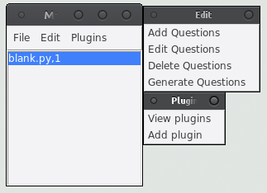
You will most likely want to pop out the Edit and Plugin menus. This is convenient when editing questions. To open an existing file, simply go to the open menu. To save your current file, hit save. This is self explanitory.

If you wish to add a question, there is a function on the edit menu for it. It will add a question in the format blank.py,1. Blank.py is the default “question”. The number after the comma is how many of the question to add.

Delete questions will delete the question set you have selected. Be careful with this, you have to re-select a new piece in the box every time.

Now lets look at the edit menu:

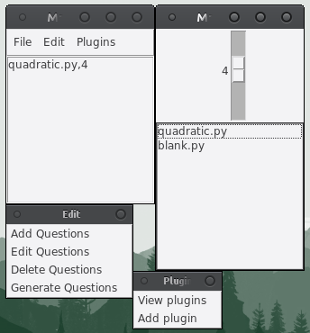

What ever you have selected on the main question menu can be changed using the edit box. The slider sets the number of questions per set (maximum ten, minimum none), and you can select the plugin to use below it. Note that this screen may look very different on windows machines, due to how tk works.

Now lets look at the plugin menu:
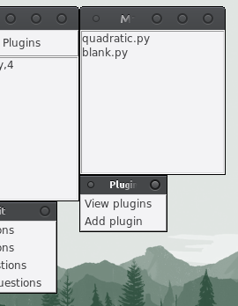
View plugins only brings up a box that shows the currently installed plugins. You can see the raw file yourself as plugs.ini. Add plugin takes a py file, copies it to the /plugs/ directory, and adds the file name to plugs.ini. Warning: I take absolutely no responsibility for what other people write and give to you as plugins. Read through what they made yourself and be careful.
If you would like information on the code itself, please look at the code. I have written many notes there.

A special thanks to:

Whoever wrote TCL/TK and TK interface. I might not like the programs themselves, but they do exactly what they say, and are very robust. Kudos to you guys for a job well done.

The author of Shutil. Although I did not use your library, you helped me understand what I needed to do to fix up my copying in the plugin load section.

And to Andy Harris. I know flattery doesn't do anything, but you teach a d*** good class.

